001-create-database

neo4j$ CREATE DATABASE testload WAIT;

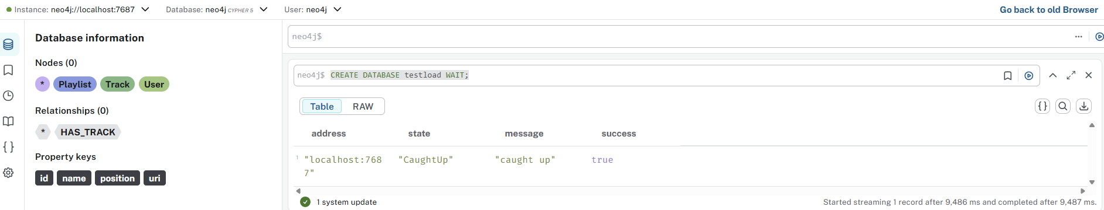

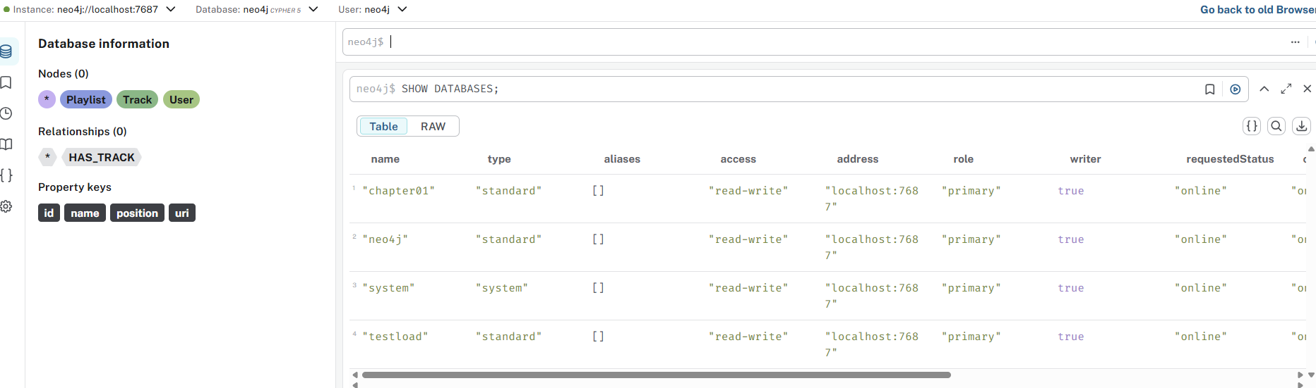

002-create-constraint

testload$
CREATE CONSTRAINT FOR (n:Track) REQUIRE n.id IS NODE KEY;

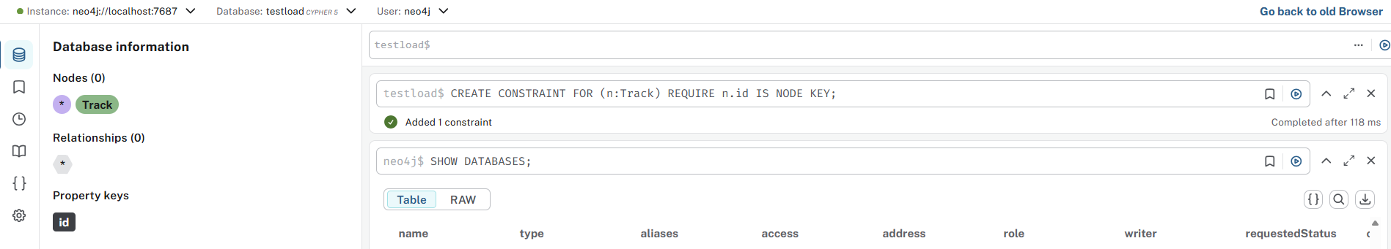

003-load-tracks

testload$
LOAD CSV WITH HEADERS FROM "file:///medium/sample_tracks_medium.csv" AS row
MERGE (track:Track {id: row.track_id})
SET track.uri = row.track_uri,
track.name = row.track_name;

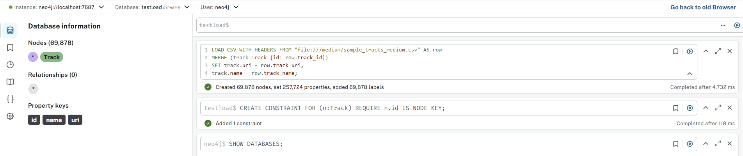

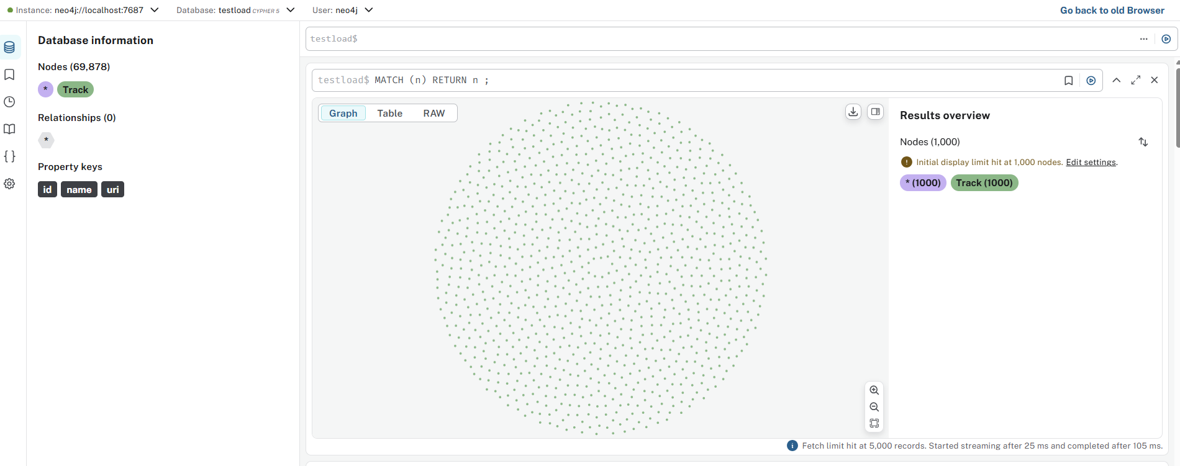

004-call-in-transactions

testload$
LOAD CSV WITH HEADERS FROM "file:///medium/sample_tracks_medium.csv" AS row
CALL(row) {
MERGE (track:Track {id: row.track_id})
SET track.uri = row.track_uri,
track.name = row.track_name
} IN TRANSACTIONS OF 10_000 ROWS;

// CALL { ... }: Executes a subquery for each row
// IN TRANSACTIONS OF 10_000 ROWS: Processes in batches of 10,000 rows

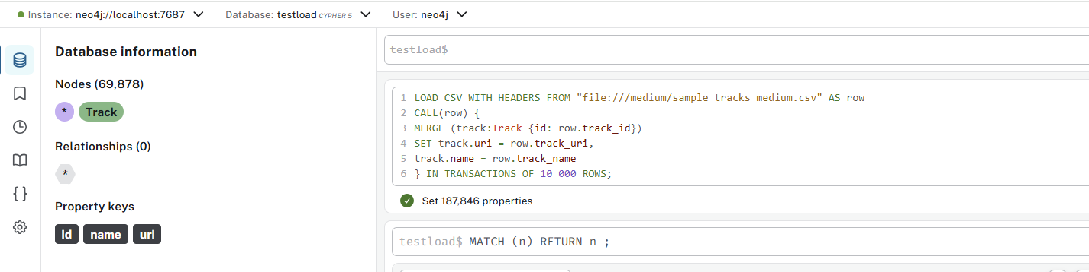

005-create-database-locking

neo4j$ CREATE DATABASE locking WAIT;

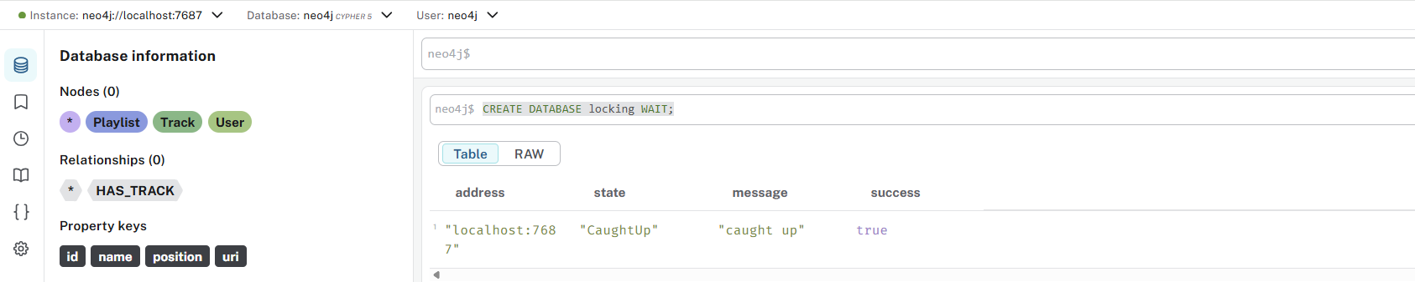

006-merge-wait-spinning

locking$
MERGE (n:Track {id: 1})
WITH n
// the transaction will be paused for 60 seconds
CALL apoc.util.sleep(60000)
// the transaction now continues
SET n.name = 'Creep'
RETURN n

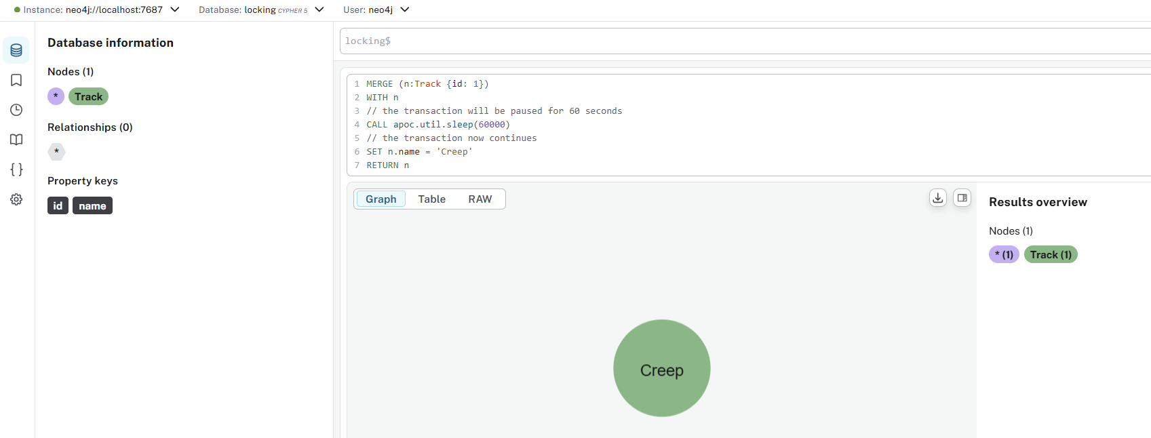

007-create-node-1

locking$ CREATE (t:Track {id: 1})

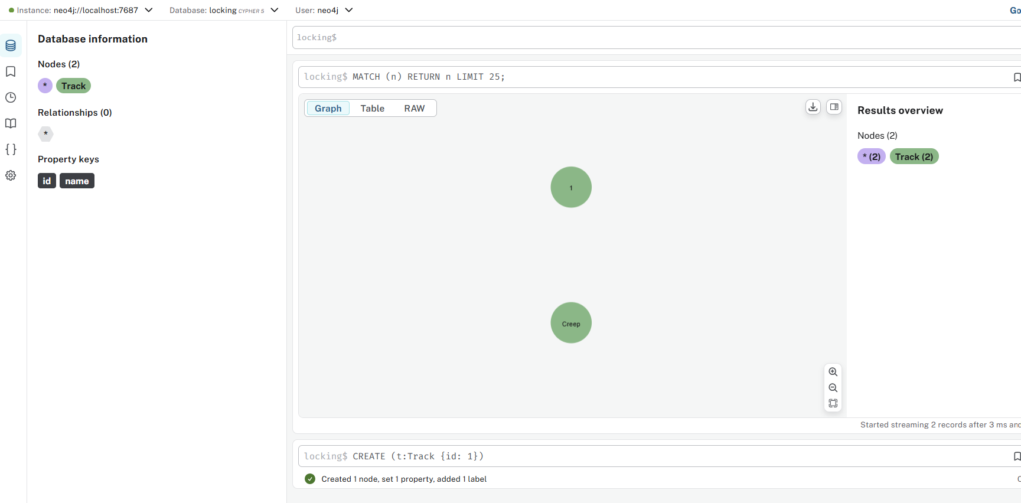

008-tab-1-1

locking$
MATCH (t:Track {id: 1})
SET t.name = 'Creep'
WITH t
CALL apoc.util.sleep(60000)
RETURN t

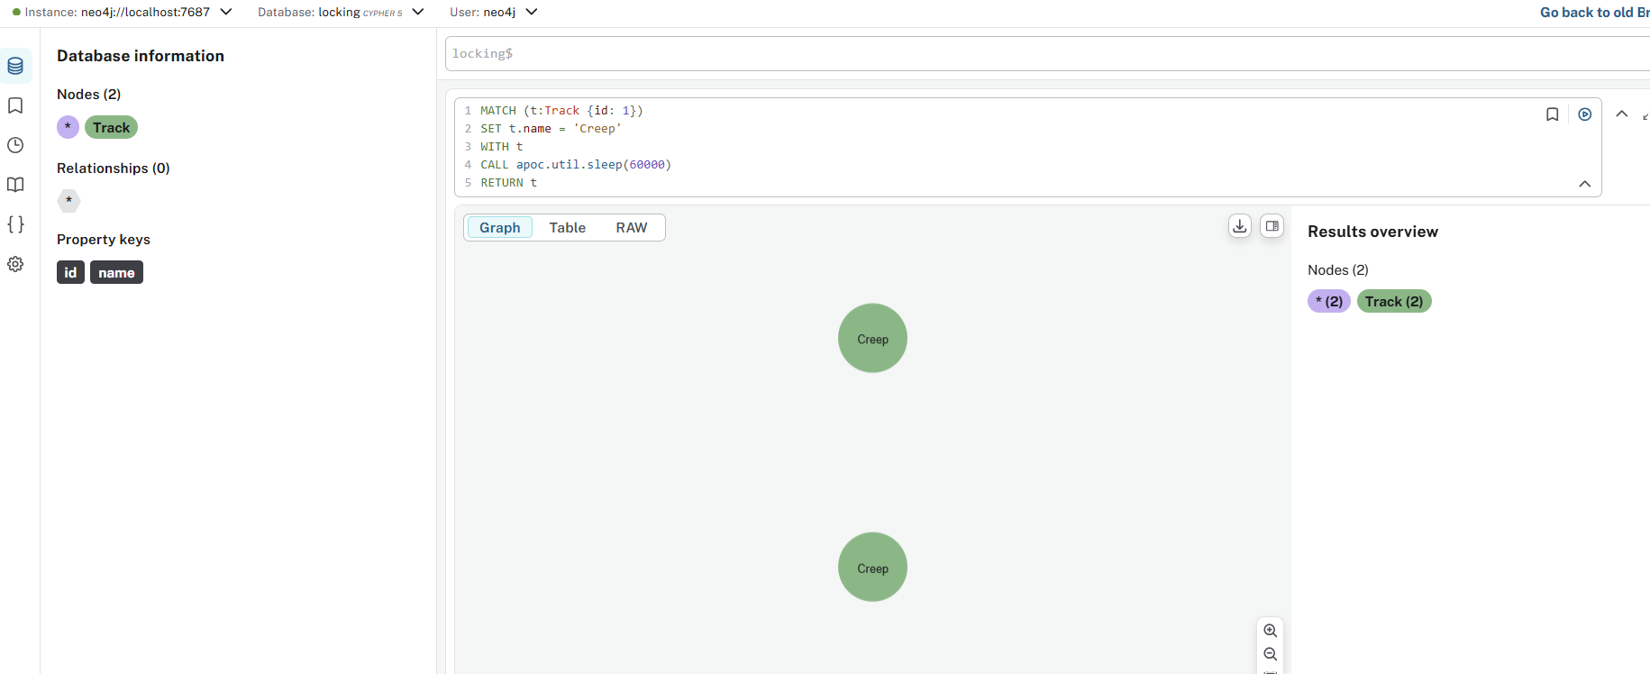

009-tab-1-2

locking$
MATCH (t:Track {id: 1})
SET t.name = 'Creep from transaction 2'
RETURN t

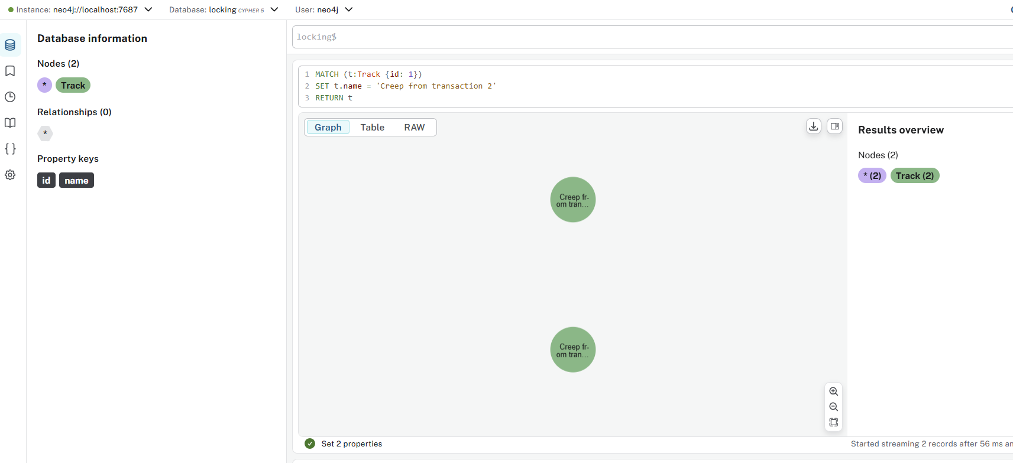

010-transactions-info

locking$
SHOW TRANSACTIONS YIELD *
RETURN transactionId, status, currentQueryId, currentQuery,
resourceInformation.lockMode AS lockMode,
resourceInformation.resourceType AS lockOnResource

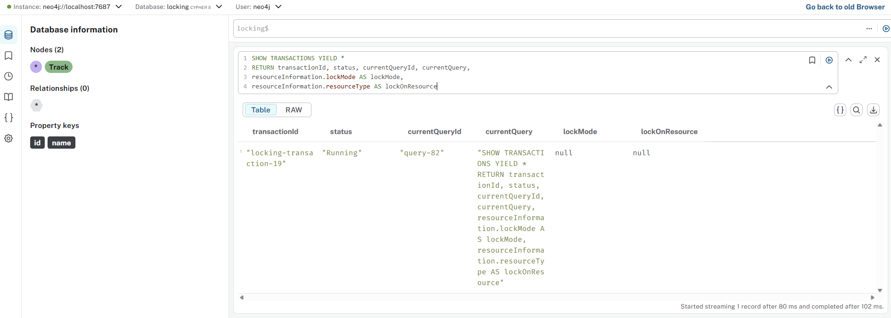

011-tab-2-1

locking$
MERGE (t:Track {id: '123'})
WITH t
CALL apoc.util.sleep(60000)
RETURN t

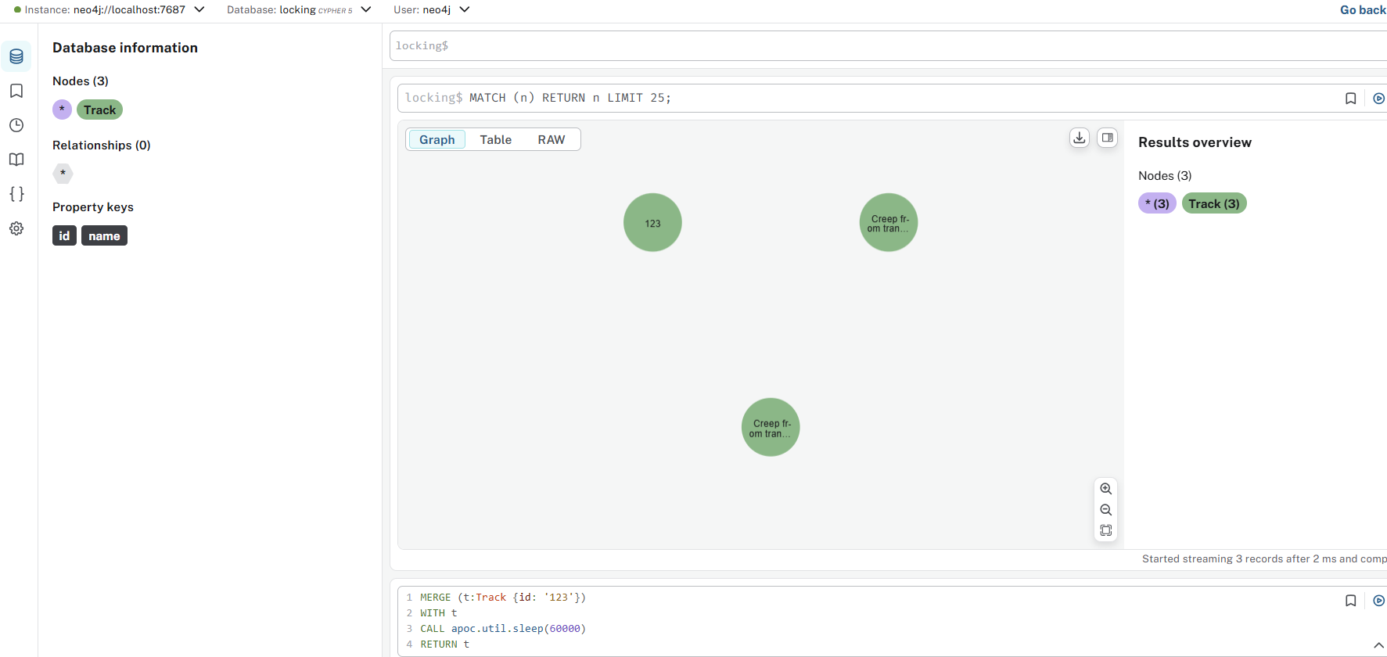

012-tab-2-2

locking$
MERGE (t1:Track {id: '123'})
MERGE (t2:Track {id: '234'})
MERGE (t1)-[:SIMILAR_TO]->(t2)

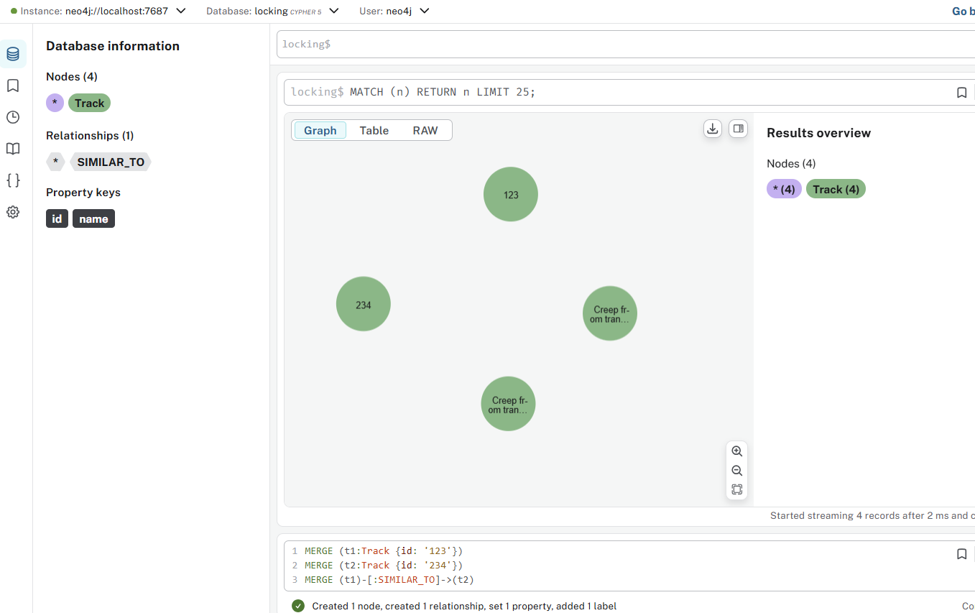

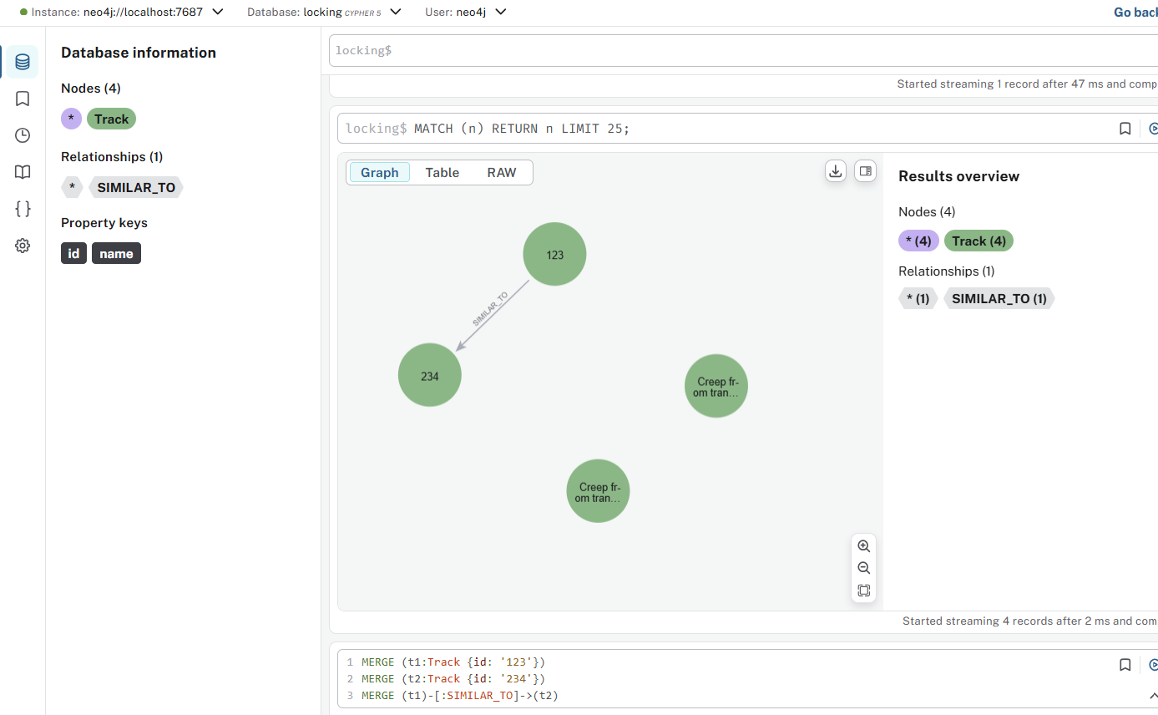

013-unique-constraint

locking$ MATCH (n) DETACH DELETE n;

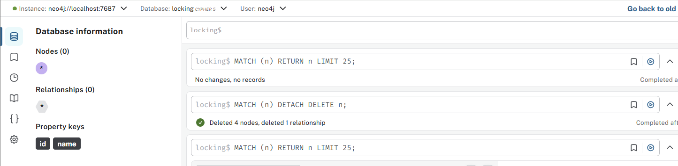

locking$
CREATE CONSTRAINT track_uk FOR (t:Track) REQUIRE t.id IS UNIQUE;

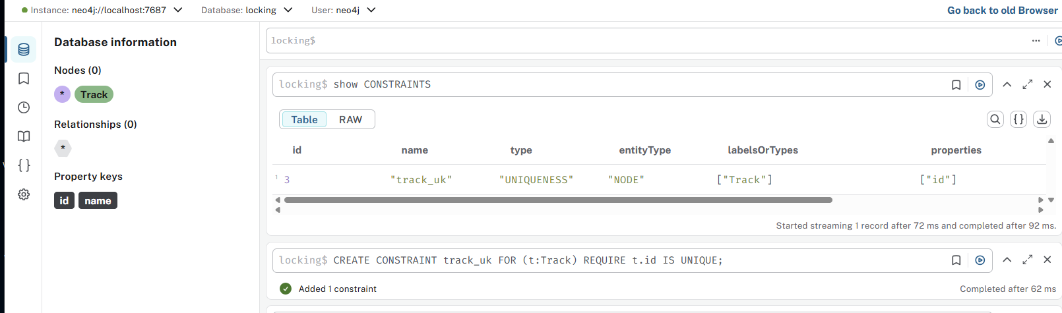

014-tab-3-1

locking$
MATCH (t1:Track {id: 1})
SET t1.popularity = 0.9
WITH t1
CALL apoc.util.sleep(60000)

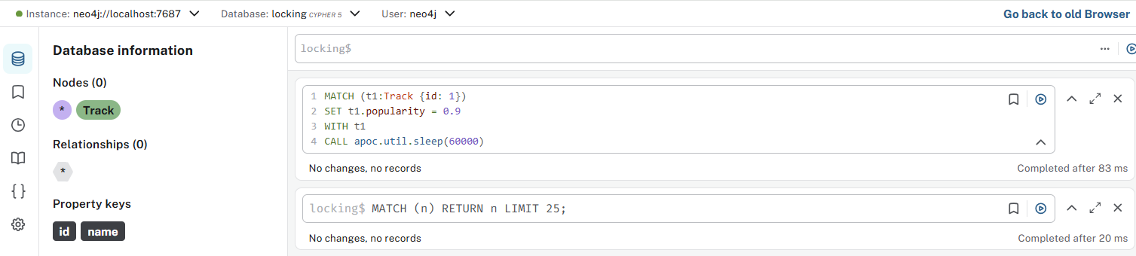

015-tab-3-2

locking$
MATCH (t1:Track {id: 1})
MATCH (t2:Track {id: 2})
CREATE (t1)-[r:SIMILAR]->(t2)

